A Project report on

Flexible AC Transmitter System Using Thyristor Switch Reactance

|  |  |  |
| --- | --- | --- |
| Name | Roll No | PRN No. |
| Rudraprasad Vishwamitre | 7049 | 22010802 |
| Deep Jadhav | 7050 | 22010818 |
| Samkit shah | 7053 | 22010866 |
| Dinesh Raut | 7058 | 22010946 |
| Dhaval Bora | 7062 | 22011010 |
| Akshay Misal | 7064 | 22011042 |

**Under the Guidance of**

Prof. V.R. Deshmukh.

**In partial fulfilment for the requirement of PROJECT BASED LEARNING (F.Y. B. TECH)**

**Course-Basic Electrical Engineering Academic Year- 2020-21**

**Semester- I**

**Department of Engineering and Applied Sciences**



**VISHWAKARMA INSTITUTE OF INFORMATION TECHNOLOGY, PUNE**

**CONTENTS: -**

1. **INTRODUCTION OF FACTS**
2. **FLEXIBLE AC TRANSMITTER SYSTEM BY USING TSR**
3. **HARDWARE COMPONENTS**
4. **SOFTWARE REQUIREMENTS**
5. **INTRODUCTION TO THE CONCEPT OF THYRISTOR**
6. **THYRISTOR SWITCHED REACTOR**
7. **CIRCUIT OF THYRISTOR SWITCHED REACTOR**
8. **ADVANTAGES OF THYRISTER**
9. **APPLICATIONS OF THYRISTOR**
10. **ADVANTAGES OF FACTS**
11. **APPLICATIONS OF FACTS**
12. **CONCLUSION**
13. **REFERENCE**

**INTRODUCTION OF FACTS**

A flexible alternating current transmission system (FACTS) is a system composed of static equipment used for the alternating current (AC) transmission of electrical energy.

 It is meant to enhance controllability and increase power transfer capability of the network. It is generally a power electronics-based system.The power flow over a transmission line depends mainly on three important parameters, namely

voltage magnitude of the buses (V), impedance of the transmission line (Z) and phase angle between buses (θ).

As FACTS devices are fabricated using solid state controllers, their response is fast and accurate. Thus, these devices can be utilized to improve the voltage profile of the system by using coordinated control of FACTS controllers in multi-machine power systems in this work.

**NEEDS OF FACT CONTROLLERS**

A [Flexible AC transmission System](https://www.elprocus.com/flexible-ac-transmitter-system-using-thyristor-switch-reactance/) refers to the system consisting of power electronic devices along with power system devices to enhance the controllability and stability of the transmission system and increase the power transfer capabilities. With the invention of thyristor switch, opened the door for the development of power electronics devices known as Flexible AC transmission systems (FACTS) controllers. The FACT system is used to provide the controllability of the high voltage side of the network by incorporating power electronic devices to introduce inductive or capacitive power in the network In a conventional AC transmission system, the ability to transfer AC power is limited by several factors like thermal limits, transient stability limit, voltage limit, short circuit current limit, etc.

These limits define the maximum electric power which can be efficiently transmitted through the transmission line without causing any damage to the electrical equipment and the transmission lines.

**FLEXIBLE AC TRANSMITTER SYSTEM BY USING TSR**

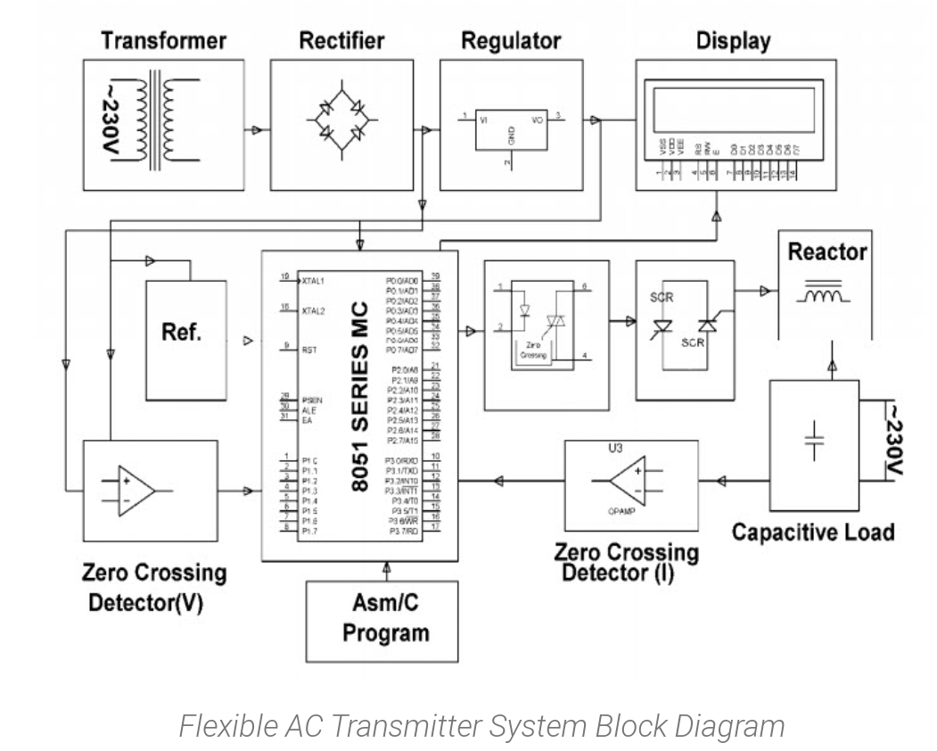

Fig.sources: https://www.elprocus.com/flexible-ac-transmitter-system-using-thyristor-switch-reactance

Fig.source: https://www.edgefxkits.com/blog/facts-flexible-ac-transmission-system-tsr

Flexible AC Transmitter System by using TSR

A Flexible AC Transmitter System (FACTS) consists of static equipment that is used for AC transmission of electrical signals. It is used to increase controllability and to increase the power transfer capability of an AC transmission system. This project can be enhanced by using firing angle control methodology for smooth control of voltage. Flexible AC Transmitter System increases the reliability of AC grids and reduces power delivery costs. They also increase the quality of transmission and efficiency of power transmission. Flexible AC Transmitter System Flexible AC Transmitter System Block Diagram This method is used while charging the transmission line or when there is a low load at the receiver end. When there is low load or no load, very low current flows through the transmission lines and the shunt capacitance in the transmission line becomes dominant. This causes voltage amplification due to which the receiver end voltage may become double than the sending end voltage.

To compensate this, the shunt inductors are automatically connected across the transmission line. In this system the lead time between the zero-voltage pulse and zero current pulse duly generated by a suitable operational amplifier is fed to two interrupt pins of the microcontroller

Flexible AC Transmitter System by using TSR

A Flexible AC Transmitter System (FACTS) consists of static equipment that is used for AC transmission of electrical signals. It is used to increase controllability and to increase the power transfer capability of an AC transmission system. This project can be enhanced by using firing angle control methodology for smooth control of voltage. Flexible AC Transmitter System increases the reliability of AC grids and reduces power delivery costs. They also increase the quality of transmission and efficiency of power transmission. Flexible AC Transmitter System Flexible AC Transmitter System Block Diagram This method is used while charging the transmission line or when there is a low load at the receiver end. When there is low load or no load, very low current flows through the transmission lines and the shunt capacitance in the transmission line becomes dominant.

This causes voltage amplification due to which the receiver end voltage may become double than the sending end voltage. To compensate this, the shunt inductors are automatically connected across the transmission line. In this system the lead time between the zero-voltage pulse and zero current pulse duly generated by a suitable operational amplifier is fed to two interrupt pins of the microcontroller

**Hardware components**

* Microcontroller (AT89S52/AT89C51)
* SCR
* Opto-Isolator

**AT89S51 Microcontroller**

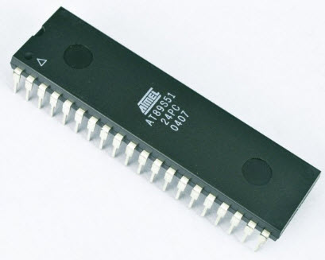

* LCD
* LM339
* Current Transformer
* Inductive load
* Shunt capacitor
* Push buttons
* LED
* 1N4007 1N4148
* Resistor
* Capacitor

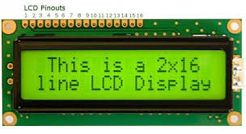**Liquid Crystal Display (LCD)**

**INTRODUCTION TO THE CONCEPT OF THYRISTOR**

**SOFTWARE REQUIREMENTS**

1. Keil Compiler
2. Languages: Embedded C or Assembly

Fig. sources: https://www.edgefxkits.com/blog/facts-flexible-ac-transmission-system-tsr/

**Quad Voltage Comparator LM339**

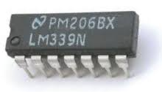

Thyristor

A thyristor is a four-layered, three-terminal semiconductor device. The four layers are formed by alternate p-type and n-type semiconductors. Thus, forming a p-n junction device. This device is also called as [Silicon Controlled Switch (SCS)](https://www.elprocus.com/silicon-controlled-rectifiers-basics-operation-applications/)because of the silicon semiconductor in it and it is a bitable device.

* Thyristor Symbol:

[A thyristor](https://www.elprocus.com/silicon-controlled-rectifier-tutorial-and-characteristics/) is a unidirectional device and can be operated as an open circuit switch or as a rectifying diode. The three terminals of the thyristor are named as the anode (A), the cathode (K), and gate (G) The anode is positive, the cathode is negative and the gate is used to control the input signal. It has two p-njunctions that can be switched ON and OFF at fast rates

Thyristor has three basic states of operation

* Reverse Blocking
* Forward Blocking
* Forward Conducting

**Reverse Blocking:** In this mode of operation, the thyristor blocks the current in the same direction as that of a reverse bias diode.

**Forward Blocking:** In this mode of operation, the thyristor blocks the forward current conduction that is normally carried by a forward bias diode.

**Forward Conducting:** In this mode of operation the thyristor has been triggered into conduction. It continues conducting until the forward current drops below a threshold level called ‘holding current’.

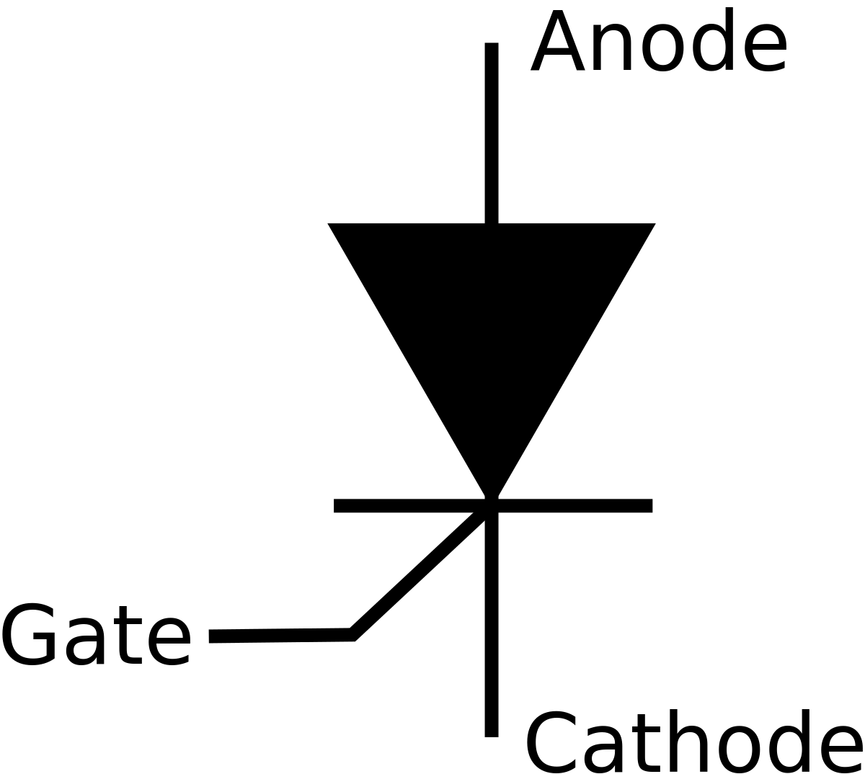

Schematically representation of Thyristor

Fig.source: https://www.edgefxkits.com/blog/facts-flexible-ac-transmission-system-tsr

**THYRISTOR SWITCHED REACTOR:**

The following circuit shows the TSR circuit. When the current flows the reactor is controlled by the firing angle of the thyristor. During every half cycle, the thyristor produces the triggering pulse through the controlled circuit. A [thyristor switched reactor](https://www.elprocus.com/tcr-thyristor-controlled-reactor-and-thyristor-switched-capacitor/) is used in electrical power transmission systems. It is a reactance connected in series with a bidirectional thyristor value.

The value of thyristor is phase-controlled, which allows the value of delivered reactive power to be adjusted to meet changing system conditions’ can be used to limit the voltage rises on lightly loaded transmission lines. The current in TSR is varied from maximum to zero by varying the firing delay angle.

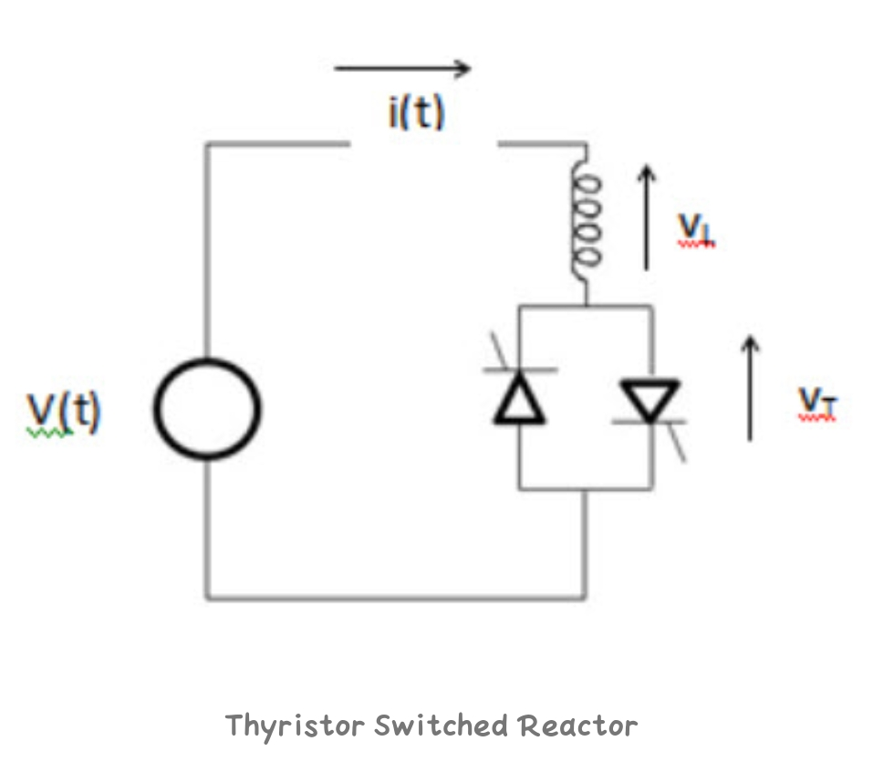

Fig.Sources: https://www.elprocus.com/wp-content/uploads/TSR.jpg

**CIRCUIT OF THYRISTOR SWITCHED REACTOR**

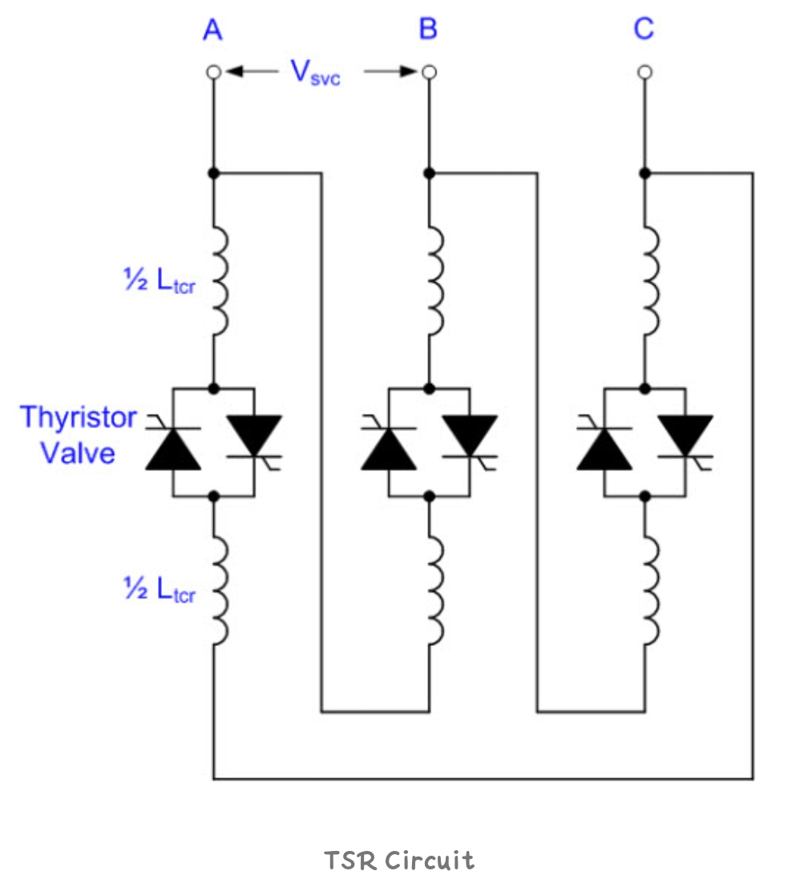

<https://www.elprocus.com/wp-content/uploads/TSR-circcuit.jpg>

A [thyristor switched reactor](https://www.elprocus.com/tcr-thyristor-controlled-reactor-and-thyristor-switched-capacitor/)is a three-phase assembly which is connected in a delta arrangement to provide partial cancellation of harmonics. The main thyristor reactor is split into two halves, with the thyristor valve connected between the two halves. This protects the thyristor reactor circuit valve from damages due to flashovers and lightning strikes

**OPERATING PRINCIPLE**

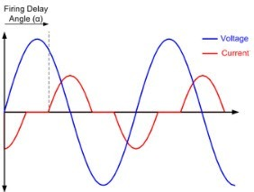

Operating Principle Representation

Fig.source: https://www.edgefxkits.com/blog/facts-flexible-ac-transmission-system-tsr

The current in the thyristor is varied from maximum to zero by varying the firing delay angle (α). It is defined as the delay angle from the point at which the voltage becomes positive to the point at which the thyristor valve is turned on and the current starts to flow. The maximum current is obtained when the α is 90 degree. At this point, TSR is said to be in full conduction.

The RMS current is given by Itsr-max = Vsvc/2πfLtcr

Where Vsvc is the RMS value of the line to line bus bar voltage Ltcr is the total TCR transducer for phase. The below waveform is the voltage and current of TCR

**ADVANTAGES OF THYRISTOR**

1. It can handle high current
2. It can handle high voltage

#### **APPLICATIONS OF THYRISTOR**

1. Used in electrical power transmission
2. Used in alternating power circuits to control alternating output power.
3. Used in inverters to convert direct current to alternating current

### **APPLICATIONS OF FACTS**

1. Damping of power system oscillation
2. Reduces generation cost
3. Steady-state voltage stability
4. HVAC (Heating Ventilation and Air Conditioning) application
5. Flicker Mitigation

**CONCLUSION**

The main objective of this proposed system is to implement FACTS by Thyristor Switch Reactance. This system is mainly used either when there is very low load at the receiving end or when charging the transmission line. Due to very less flow of current through the transmission line and also shunt capacitance in the transmission line turns into main. This causes voltage amplification due to which getting end voltage may turn into double than the sending ends voltage. To balance this, shunt inductors are routinely connected across the transmission line.

In this project, the lead time between the zero-voltage pulse and zero current pulse duly produced by apt Op-Amp (operational amplifier) are fed to 2- interrupt pins of the microcontroller, where the microcontroller program takes over to carry the shunt reactors to the circuit to get the voltage duly compensated. Back to back SCRs duly connected through optical isolation from the 8051-family microcontroller are used in series for switching the reactor. From the above information, finally, we can conclude that the Flexible AC Transmission by TSR (FACTS) is a new technology used to give an opportunity to increase stability, controllability and power transfer ability of AC transmission systems. Further the project can be developed by using firing angle control method for smooth control of the voltage. Therefore, this is superior to switching reactors in steps where voltage control is not very precise.

**Reference**

* <https://electrical-engineering-portal.com/facts-devices-to-enhance-power-system-performance>
* <https://www.elprocus.com/flexible-ac-transmitter-system-using-thyristor-switch-reactance>.
* <https://www.edgefxkits.com/blog/facts-flexible-ac-transmission-system-tsr>
* <https://www.academia.edu/8221992/FACTS_Flexible_AC_Transmission_System>
* <https://www.ijert.org/research/flexible-ac-transmission>
* https://examcraze.in/bl-theraja-pdf-book